CCH HALLOWEEN PARTY

Wednesday, October 31st (rain or shine)

5:00 - 6:00 P.M.
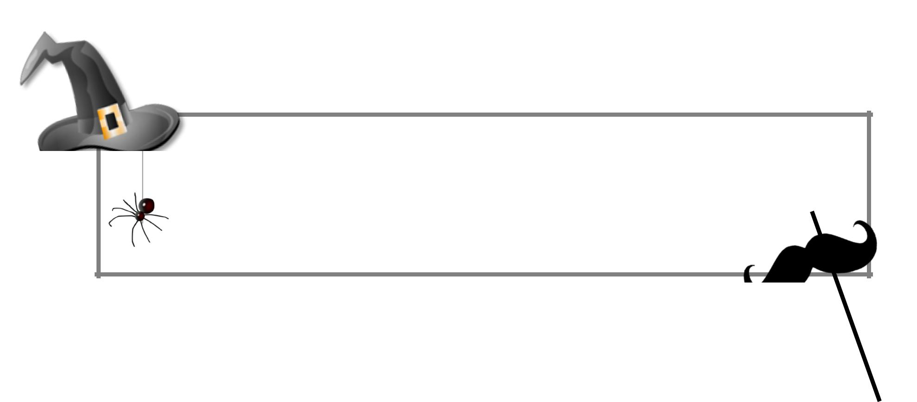

at The Commons

Spring Lake Terrace & Andover Drive

Pizza  Popcorn  Lemonade Bring a side to share!

Contact: Jason Gray, 703.691.4163, social@cchca.org

